For Immediate Release
Contact: Siobhan Olson, 336-769-6365, Siobhan@FeistyPR.com

MAUI JIM PACKS YOUR SUMMER FULL OF COLOR

Lahaina, HI, June 8, 2014 – As summer’s flowers spring into bloom, you’ll want to put on a pair of Maui Jim’s newest sunglasses with the only lenses designed to bring out the rich colors in the world around you. This summer, the company’s notable PolarizedPlus2® lenses have been popped into five new women’s styles that come in the shades of the flora and fauna of the season.

All Maui Jim lenses use patented PolarizedPlus2® lens technology that has received the Seal of Recommendation from The Skin Cancer Foundation as an effective UV protectant because the technology cuts 99.9 percent of glare and eliminates 100 percent of UVA and UVB rays while significantly boosting color, definition and depth perception. Maui Jim’s sunglasses are recognized as safe and effective sun protection and are an important part of an effective defense program against skin cancers of the eye and eyelids.
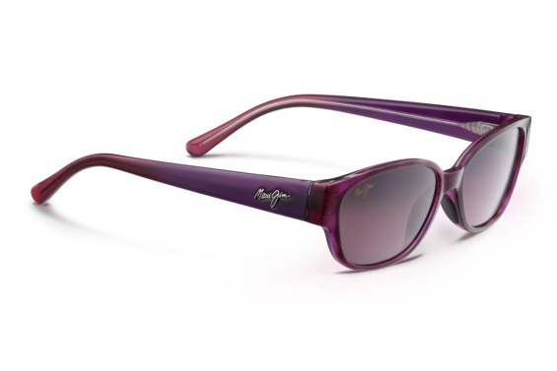
If a rich, purply-red, reminiscent of bougainvillea flowers, is your color-of-choice this season, discover Maui Jim’s Anini Beach in Amethyst with Maui Rose™ lenses (Style #269, $219 US MSRP). This is a sophisticated slight-cat-eye style that complements petite faces. The nylon frame softly curves into a rectangular shape that is accented at the outer top edges with a boxy upturn that flows into articulated temples. With the Amethyst frame, the Maui Rose™ lenses bring a soft rosy color to your world. Other duo-toned options are designed to accent skin tone and eye color in Gloss Black with Light Blue and Neutral Grey lenses; Gloss Tortoise and Peacock Blue with HCL™ Bronze Lenses; and Tortoise and Blush with HCL™ Bronze Lenses. This style features Maui Jim’s ST (SuperThin) Glass lenses that are 20 percent thinner and lighter than conventional glass lenses. Key measurements include an eye size of 53 mm; the shortest distance between lenses is 16 mm; temple length is 135 mm; and the glasses have a 6-base curvature. They are available with MauiPassport® prescription lenses.

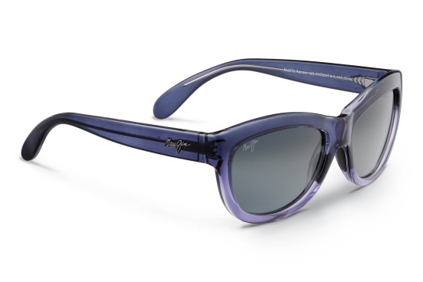
If the deep violet color of a summer iris is your style, Maui Jim brings ladylike elegance to Kanani (Style #270, $219 US MSRP) in Twilight Fade with Neutral Grey lenses. Meaning “the beautiful one” in Hawaiian, these sunglasses are designed to make a statement by updating the best eyewear features of a soft, cat-eye shape in trend-setting colors and finishes merged with high-tech sun protection features. Kanani’s chunky, vintage shape is transformed by translucent colorations and duo-toned styling. They have lightweight nylon frames and Super Thin (ST) glass lenses that are 20 percent thinner and lighter than conventional glass lenses. Other color options include Tortoise/Peacock Blue with HCL Bronze lenses or a more muted Grey Tortoise with Maui Rose lenses This style has an eye size of 57 mm; bridge size of 19 mm; and temple length of 135 mm, as well as a 6-base curvature. They are available with MauiPassport® prescription lenses.
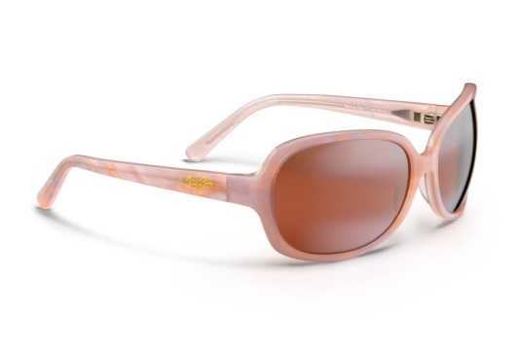
The pale pink look of Rainbow Falls (Style #225, $319 US MSRP) is a stand-out, especially in Abalone and White with Maui Rose lenses. The sun rises on this large-scale, glamorous frame with swirls of color in a hand-patterned, high-grade nylon wrap sunglass. This frame is not only stylish, but it can withstand a wide range of activities because the Maui Evolution® lenses offer high-performance optics combined with scratch- and impact-resistant properties. Rainbow Falls can go from vespa to the beach and not miss a beat. This style is also available in Cinnamon/Bubblegum with HCL Bronze lenses or beautiful White Pearl/Lilac with Maui Rose lenses. This style has an eye size of 63 mm; bridge size of 17 mm; and temple length of 120 mm, as well as an 8-base curvature. They are available with MauiPassport® prescription lenses.
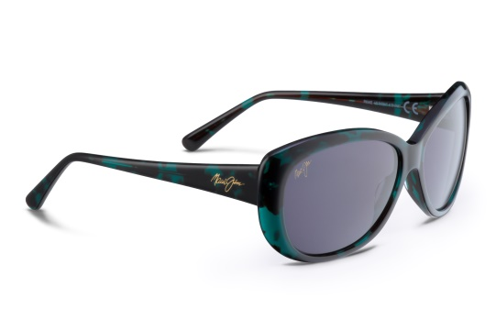
Emulating the rich underwater, blue/green color of the ocean, Pikake in Emerald with Neutral Grey lenses (Style #290, $319 US MSRP) offers a translucent, slight cat-eye look for the season. This rounded, lightweight acetate frame complements medium-sized square or rounded face shapes. The anti-corrosive spring hinges and saddle-style fixed nose bridge provide a secure, comfortable fit. You will see the world like you’ve never seen through brilliantly clear Maui Evolution lenses® that offer high-performance optics combined with scratch- and impact-resistant properties that can withstand the rigors of a wide range of activities. This graceful style also comes in Teal Fade to Grey Stripe with Neutral Grey lenses and Honey Tortoise with HCL® Bronze lenses. Pikake has an eye size of 61 mm; the shortest distance between lenses is 15 mm; temple length is 135 mm; and the glasses have a 6-base curvature. They are available with MauiPassport® prescription lenses.
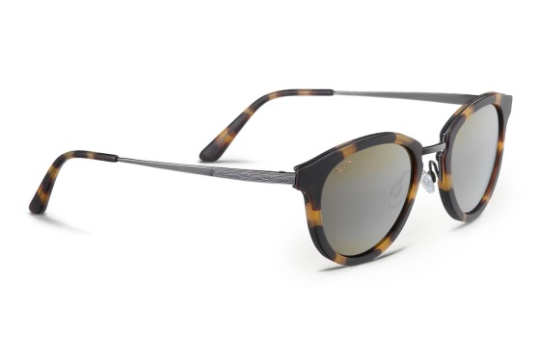
If a flirty, updated tortoise look is what you’re going for, Kolohe in Matte Tortoise with Antique Pewter and HCL™ Bronze lenses (Style #263, $299 US MSRP) takes their cue from 30 years ago in eyewear fashions. Maui Jim is bringing to market a new collection of vintage eyewear designs that offer undistorted and spectacularly colorful views through the company’s patented PolarizedPlus2® lenses. Kolohe is a celebration in vintage round design with its combination of a thin nylon front paired with slim, brushed silver/nickel temples and features Maui Jim’s proprietary MauiPure™ lenses – the world’s clearest non-glass lenses that are ultra-lightweight, scratch- and impact-resistant. Kolohe also comes in Gloss Black with Antique Pewter with Neutral Grey lenses and Tortoise with Antique Gold and HCL™ Bronze lenses. Key measurements include an eye size of 50 mm; the shortest distance between lenses is 23 mm; temple length is 140 mm; and the glasses have a 6-base curvature. They are available with MauiPassport® prescription lenses.
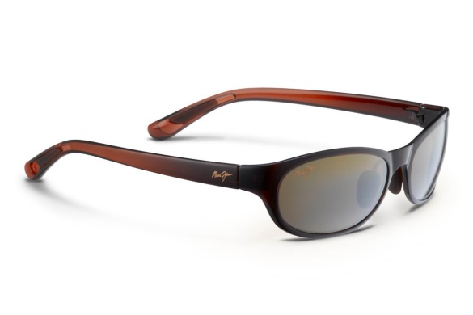
For a hike through the redwoods, Pipiwai Trail in Rootbeer Fade with HCL™ Bronze Lenses (#416, $229 US MSRP) are the lightest pair of full-frame sunglasses that can go the distance. A new addition to Maui Jim’s new PureAir™ series of sunglasses, Pipiwai Trail is designed for small to mid-sizes faces. They use Maui Jim’s proprietary MauiPure™ oval-shaped lenses which are the world’s clearest non-glass lenses that are ultra-lightweight, scratch- and impact-resistant. MauiPure lenses also are protected with waterproof and oleophobic coatings to shed water and snow and to repel grease and smudges. PureAir frames use the new Grilamid TR90LX, a thermo-plastic that is known for its durability and ability to retain its shape, even when the material is thin or flexed. This material also has the ability to be clear and transparent and to be colored in transparent or opaque applications, allowing for a wide range of creativity in eyewear design. Pipiwai Trail comes in three color combinations: Gloss Black Fade with Neutral Grey lenses for bright, sunny days; Rootbeer Fade with HCL™ Bronze lenses for variable light conditions; Grey Fade with Maui Rose lenses that enhance contrast; and Olive Fade with Maui HT lenses to brighten dark days. The temples and adjustable nose bridge use Rubberon for extra gripping power. Key measurements include an eye size of 56 mm; the shortest distance between lenses is 18 mm; temple length is 127 mm; and the glasses have an 8-base curvature for well-rounded comfort. They are available with MauiPassport® prescription lenses.
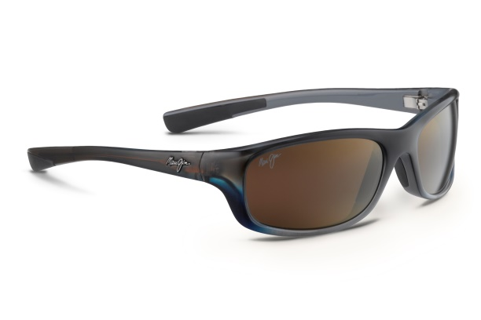
While out at sea, you’ll encounter the iridescent brilliance of fish of all colors. So, this summer, discover Kipahulu in Marlin with HCL™ Bronze Lenses (STYLE #279, $239 MSRP). Adding to its collection of 112 sunglasses for a wide range of outdoor activities, this is a full-frame nylon styles that wraps your eyes with the maximum sun protection. The ST (SuperThin) Glass lenses deliver clear, undistorted views and are 20 percent lighter and thinner than conventional glass lenses. They feature anticorrosive spring hinges and embedded rubber nose pads and temples for added stability and comfort. The two-toned Marlin frame color gradually transition from a rich glossy grey/brown to an iridescent blue emulative of the fish’s coloring. They have HCL™ Bronze lenses for superior protection in variable light conditions. Kipahulu also comes in Gloss Black with Neutral Grey lenses and Matte Tortoise Rubber with HCL Bronze lenses. Kipahulu fits small to mid-size faces with an eye size of 59 mm, bridge of 19 mm, temple of 120 mm and an 8-base curve. They are available with MauiPassport® prescription lenses in powers from +3.00 to -6.50.

Maui Jim has been voted favorite sunglasses company and best sunglasses by optical retailers and many of the top health, fitness and outdoor sports media around the world. All Maui Jim sunglasses have been awarded the Seal of Recommendation from The Skin Cancer Foundation as an effective UV filter for the eyes and surrounding skin. For more information, visit MauiJim.com or follow us on Facebook, Twitter or Pinterest at @OfficialMauiJim.

# # #

